Technology Architecture

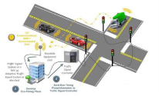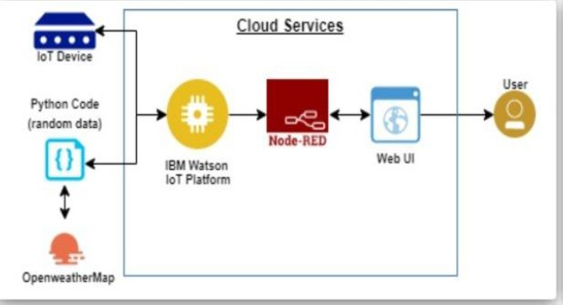

Status about the pipeline hole Cloud processing using python code
The user can see the hole condition and laser sensor in smart board

